COMPUTER SCIENCE & ENGINEERING
Vision
To produce technically competent professionals in Computer Science and Engineering through
quality teaching – learning environment to meet the needs of Academia, Industry and Society.
Mission
- M1: To impart technical knowledge and skills with quality teaching – learning process and supportive infrastructure facilities.
- M2: To motivate students towards lifelong learning and help them to find right career opportunities.
- M3: To inculcate the qualities of leadership, personality development and social responsibility in the students.
Program Educational Objectives Statements
- Obtain a strong technical foundation to pursue higher education.
- Pursue a successful career utilizing his/her education to become an excellent employee or entrepreneur.
- Become socially responsible with good leadership qualities, ethical values and effective interpersonal skills.

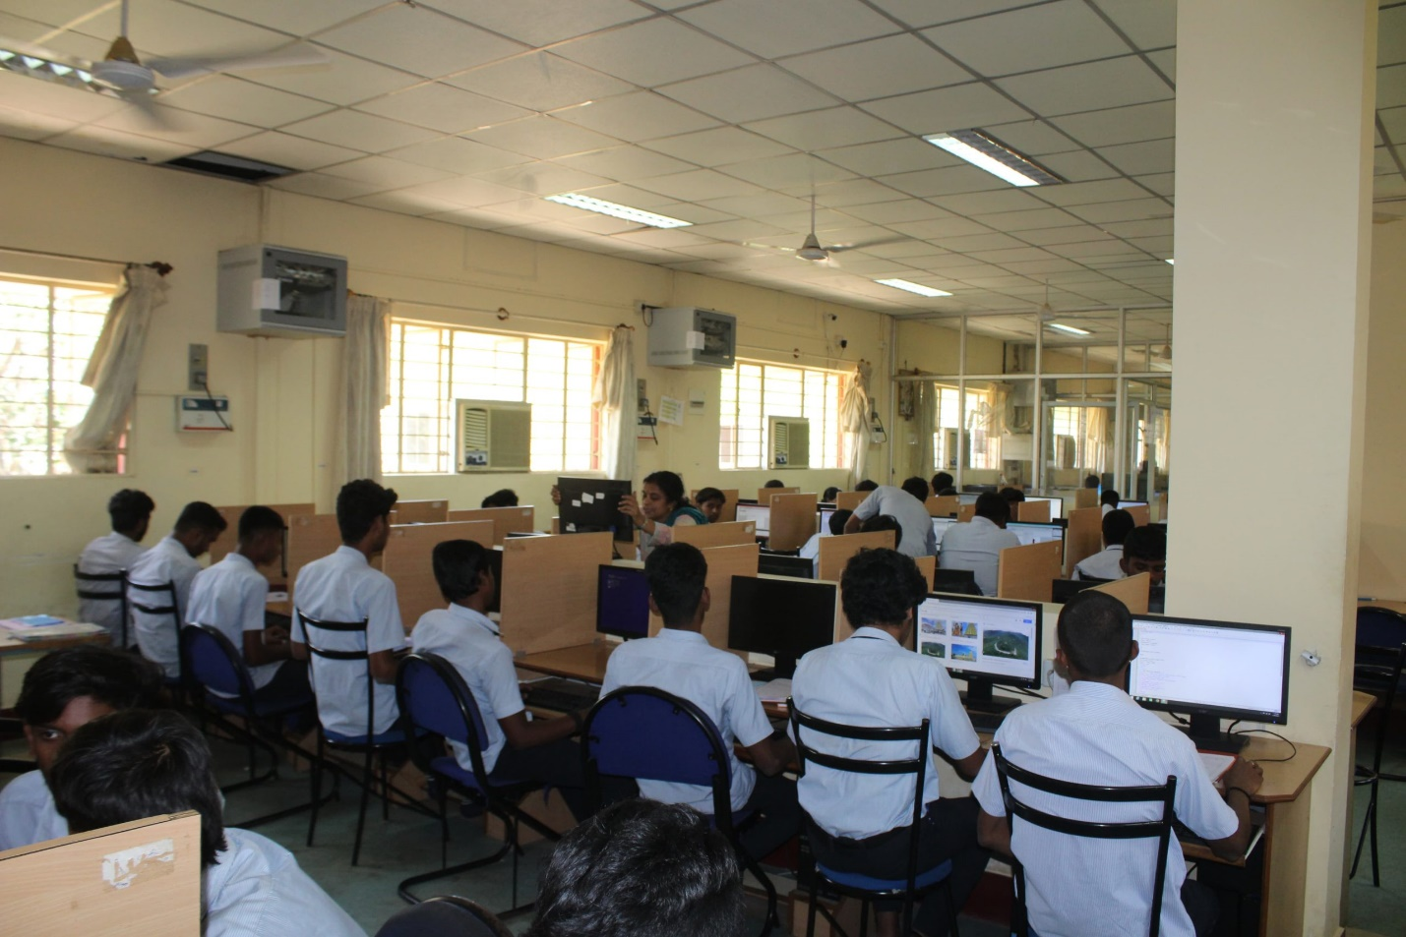
CS LAB

FROM HOD’S DESK
The Department of Computer Science and Engineering (CSE) was established in the year 1987. It is recognized by DTE, Bengaluru and affiliated to AICTE, New Delhi. The current intake of students is 60.The department has well equipped computer labs, in accordance with the curriculum.
Most of the students opt for higher education after Diploma. Out of these, many of them secure top ranks in DCET and pursue higher studies in prestigious engineering colleges, like RVCE (Bengaluru), PES (Bengaluru) and SJCE (Mysuru), and NIE (Mysuru).
We also have students whoare placed in reputed companies, such as Infosys, Wipro, and Theorem. In addition to handling sessions, our dedicated staff members mentor students and motivate them to be technically competent and socially responsible
note: All the faculties nature of association is regular Employees
Achievements
LIST OF TEACHING FACULTY
Sl no | Image | Name | DESIGNATION | QUALIFICATION | Date of Joining | Profile
 | 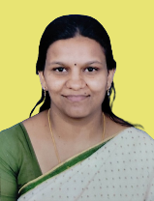 | Shinu Koshy | HOD | MTech | 30/7/2003
 | 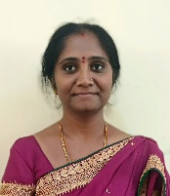 | Sowmyashree.H.G | Lecturer | MTech | 14/7/2006
 | 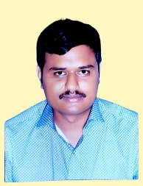 | Lokesha. K.R | Lecturer | MTech | 17/7/2006
 | 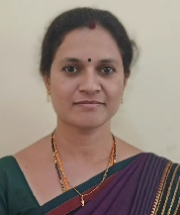 | Somaprabha .S | Lecturer | BE | 29/1/2008
 | 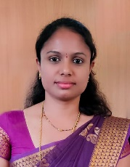 | Shruthi. S | Lecturer | MTech | 10-03-2009
 | 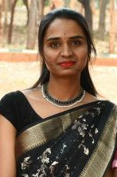 | Keerthana M | Lecturer | BE | 18/1/2024

Student placed in prestigious colleges
Academic year | RVCE, Bengaluru | SJCE, Mysuru | NIE, Mysuru
2018 | 1 | 7 | 4
2019 | 4 | 10 | 0
2020 | 1 | 9 | 8
Total | 6 | 16 | 12
- 3 day state level workshop for faculty on newly introduced ‘Statistics and Analytics Lab’ in C-20 curriculum with around 150 participants conducted.
- 5 days State Level FDP on Full Stack Development conducted.
- Alumni placed in reputed companies in India and Abroad
- Encouragement for toppers and 100% attendance students
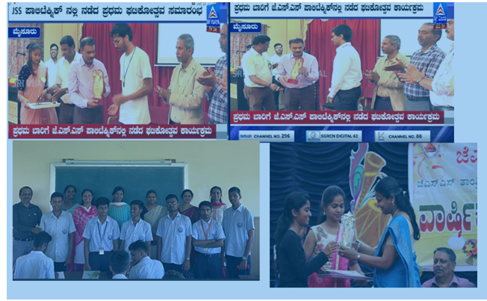
- Industry visits, workshops, technical talks by industry experts arranged frequently for exposure of students.
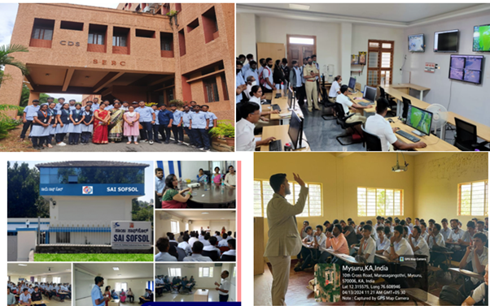
- Educating public about security in E-transactions in Suttur Jathra exhibition
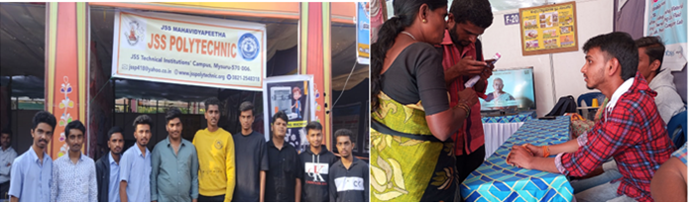
To Get to know about Distinguished Alumni of Computer Department download the below document.
List-of-Distinguished-AlumniDownload
